**Tableau Worksheet Exercise**

Please use the screenshots ONLY as a reference. The written instructions have to be followed AS written.

PLEASE MAKE SURE YOU SUBMIT ALL THE SCREENSHOTS WITH TIMESTAMPS AT THE BOTTOM RIGHT (WINDOWS USERS) OR ELSE YOU WILL AUTOMATICALLY QUALIFY FOR A DISCOUNT.

**Objective:**

To understand how to make charts in Tableau by implementing join, aggregation, sort and filter techniques in a worksheet.

**Step 1: Prerequisite**

Before you can begin, your computer needs the Tableau Desktop installed and working.

* Tableau is a business intelligence tool used for data visualization. It turns data into meaningful insights.

**Step 2: Installation of Tableau Desktop**

1. Click on the link below and select “Get Tableau for free”

<https://www.tableau.com/academic/students>

1. On the form, enter your school email address for Business E-mail and enter the name of your school for Organization.
2. Once Tableau is installed, activate it with the product key listed in the associated document.

**Step 3: Connecting to a Data Source**

1. Launch Tableau from your desktop.
2. Click on “Sample – Superstore” as shown in the screenshot below.

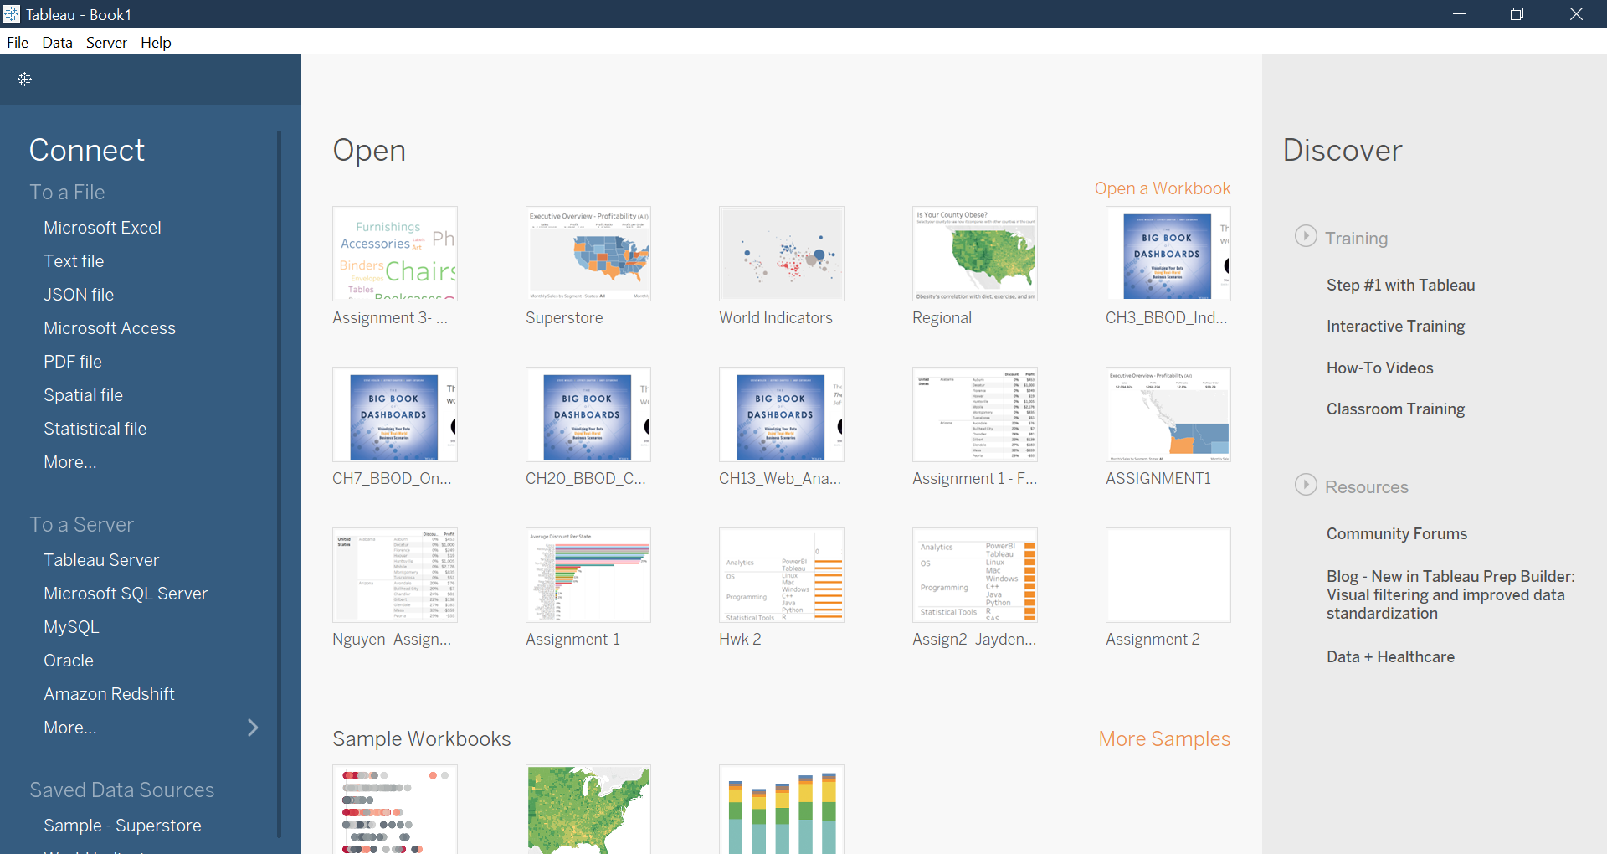

1. Select the Sample – Superstore data set. This is a sample dataset provided by Tableau. The data set includes sales data for a big box Superstore (Walmart, Target, Home Depot).

**Step 4: Exploring the Dataset**

The resulting screen is called a worksheet. It provides shelves to drag and drop dimensions and measures to construct a visualization.

1. Dimensions contain qualitative values (such as names, dates, or geographical data). It is used to categorize, segment, and reveal the details in the data.
2. Measures contain numeric, quantitative values that can be measured. It can be aggregated.
3. Click on the “Data Source” button at the bottom left part of your screen.

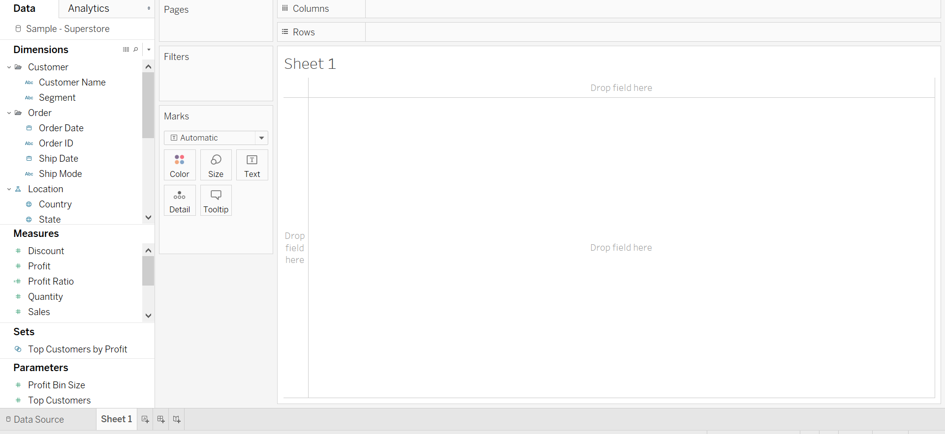

Question 1: Paste the screenshot of the resulting screen.

1. Click on the “View Data” icon next to the Orders table

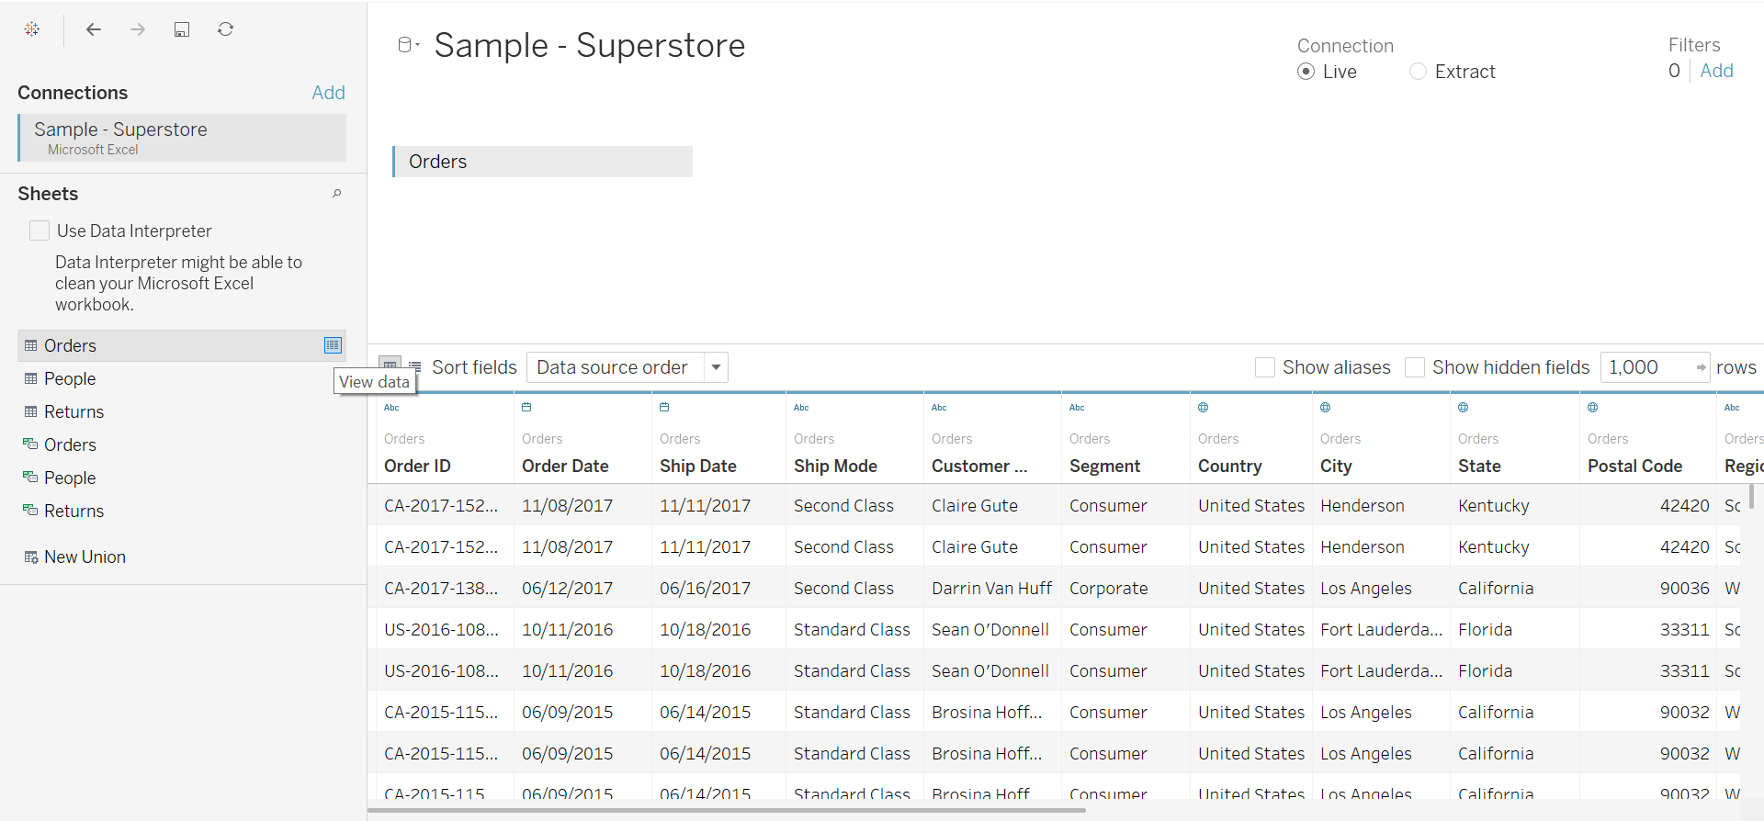

Question 2: Total how many tables are there in the loaded dataset? What is the total number of rows in the orders table? What is the total number of columns in the Orders table?

**Step 5: Joins**

Joining is a method for combining the related data on common fields. The result of combining the data using a join is a virtual table that is typically extended horizontally by adding columns of data.

To implement a join, drag the sheet/table from the left side onto the open window pane shown below.



Question 3: Paste a screenshot of your join between the Orders and the Returns table. List the type of join being implemented.

**Step 6: Rename Worksheet**

1. Click on the “Sheet 1” icon on the bottom to go back to the worksheet.
2. Double click or right click on “Sheet 1” and rename it to your “Firstname_Lastname”.



Question 4: Paste a screenshot of the renamed worksheet.

**Step 7: Aggregation**

1. Drag the Category variable from Dimensions to the Columns shelf.

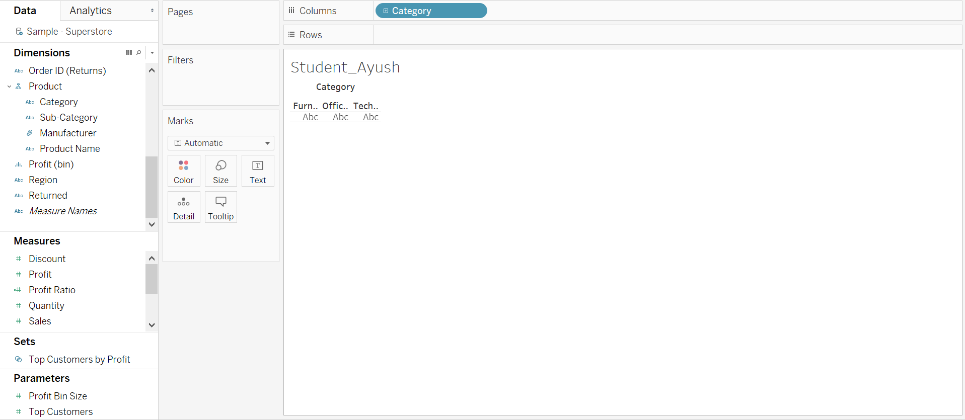

1. Now drag Profit from Measures to the Rows shelf.

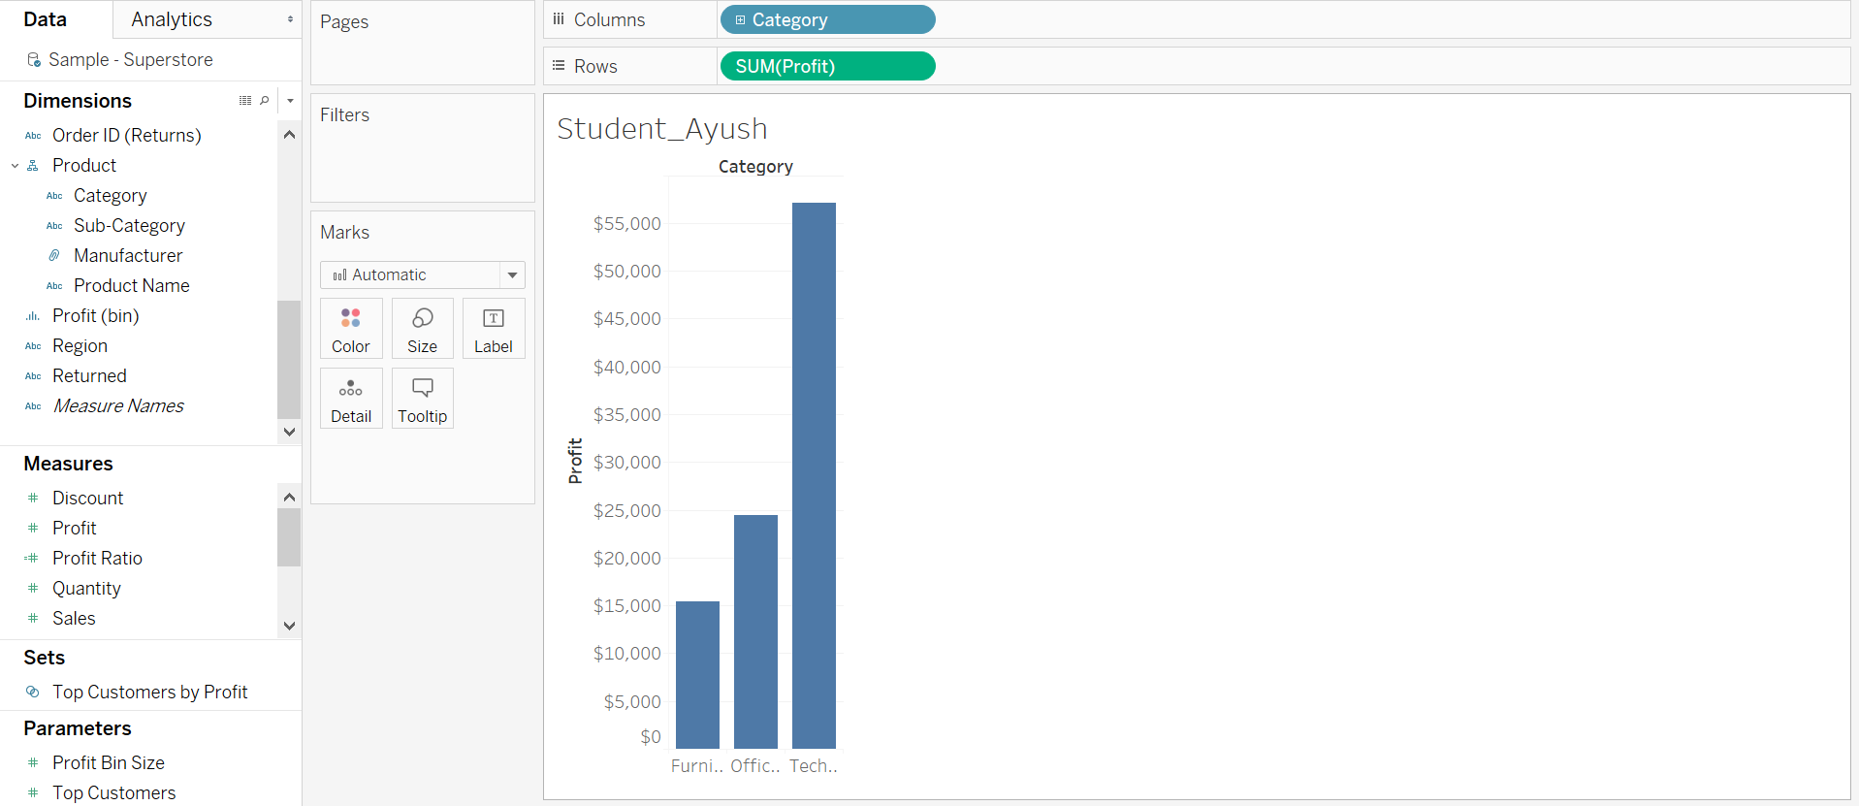

Question 5: What is the default aggregation in Tableau?  
a) Mean  
b) Sum  
c) Median  
d) Count

1. Hover the mouse over the green pill, click on the small white triangle and select “Average” from the Profit Measure.

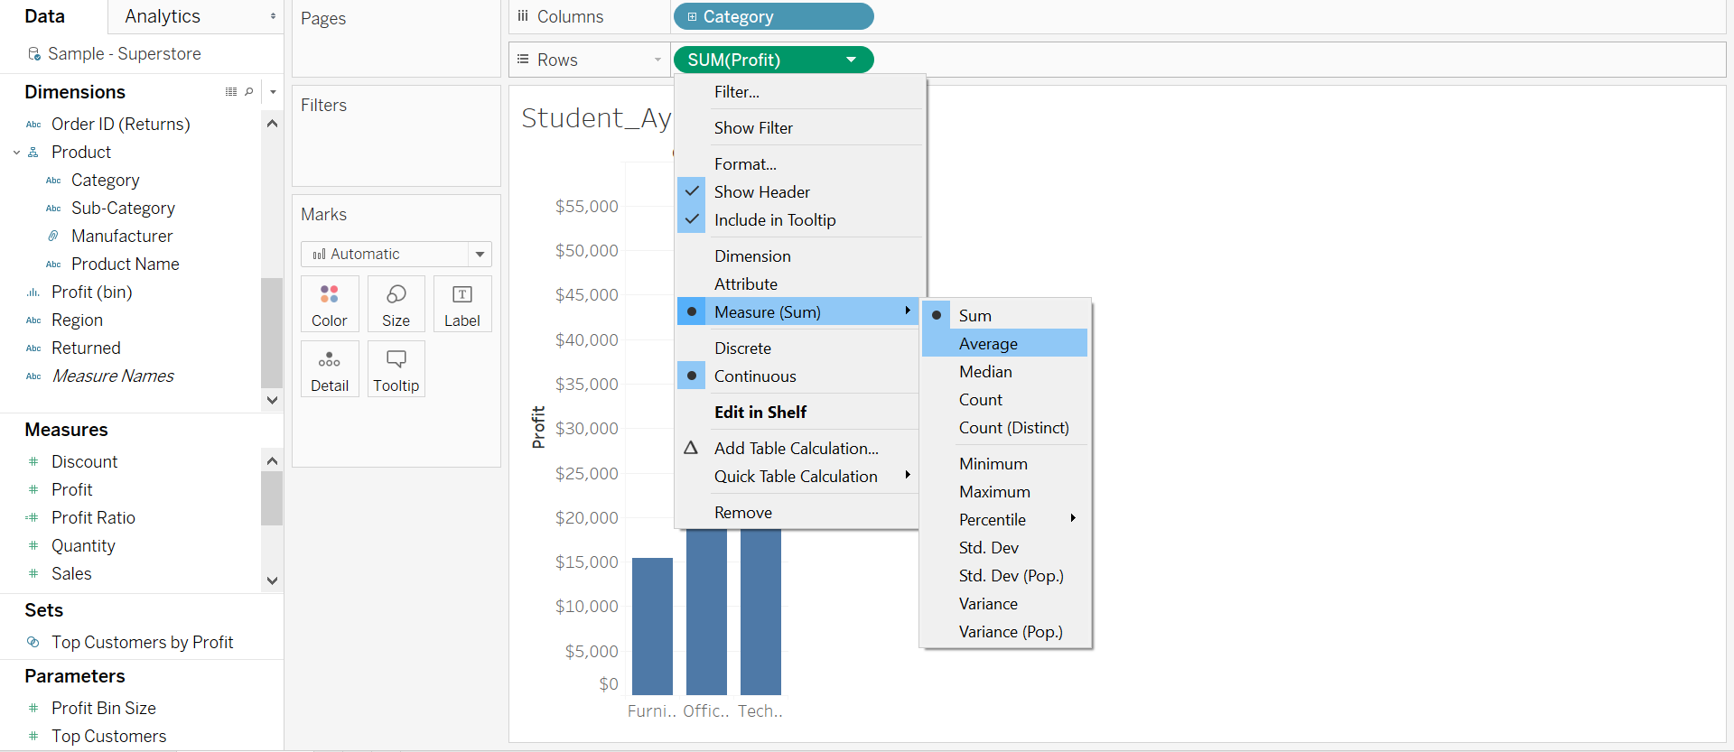

1. Select “Entire View” as shown in the below screenshot.

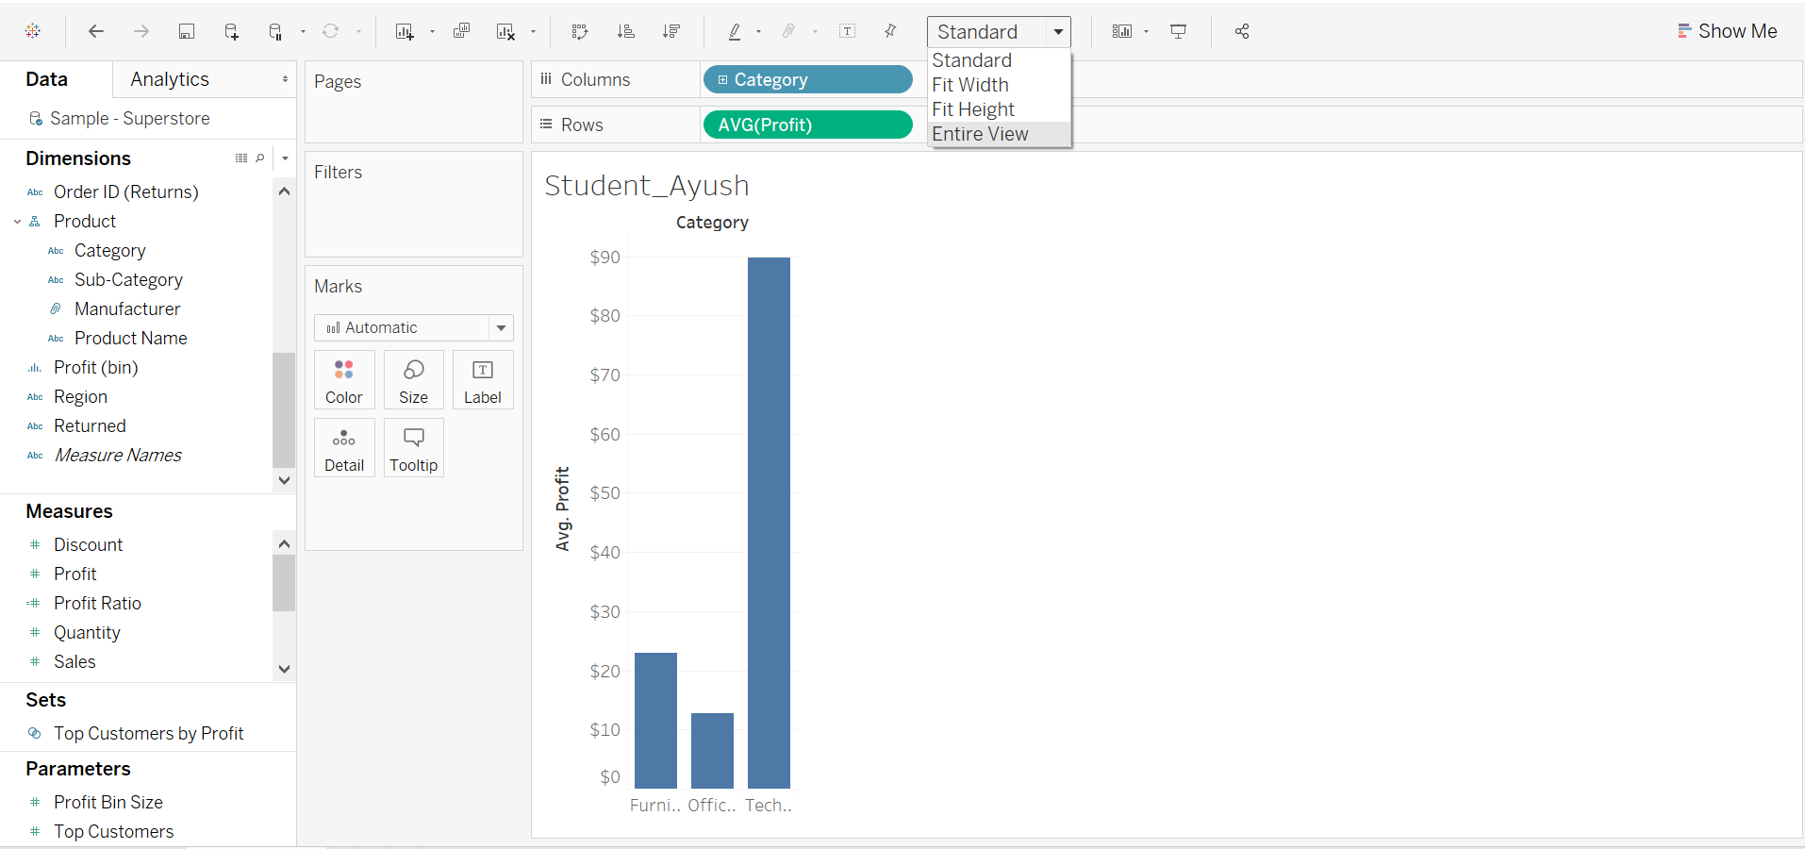

5. Rename the current worksheet to “FirstName - Bar Chart”

Question 6: Paste the screenshot of your screen showing the entire view.

Question 7: What changes were observed in the bar graph when aggregation was changed from sum to average?

**Step 8: Filters**

1. Create a new worksheet by clicking at the bottom worksheet icon. Also, rename the new worksheet as “FirstName – Scatter Plot”



1. Drag the “Profit” measure to the Columns shelf. Drag “Sales” from Measures to the Rows shelf.

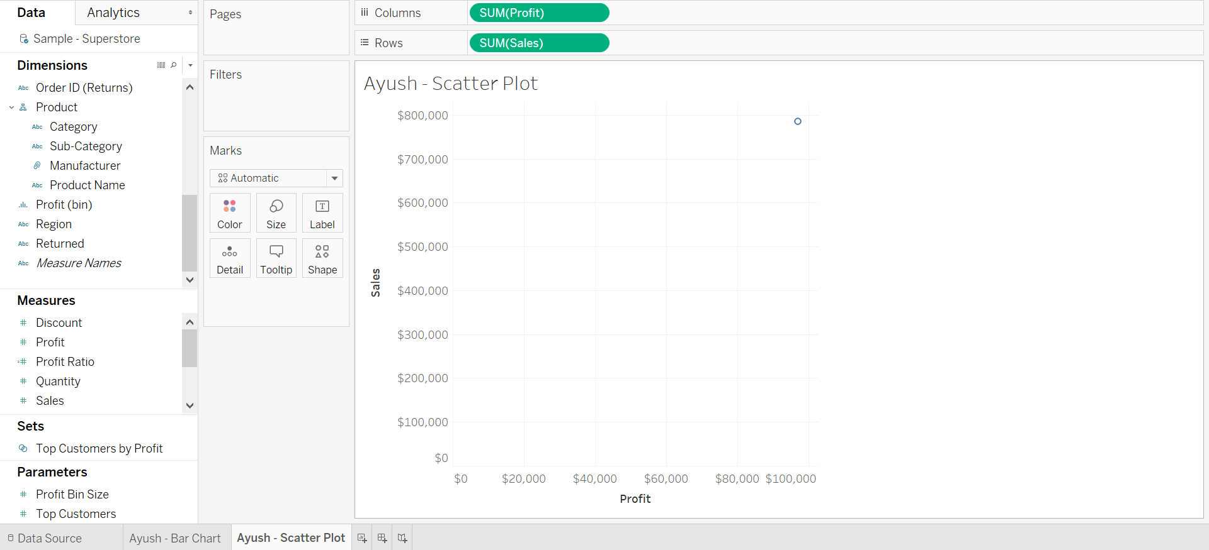

1. Drag “Sub-Category” from Dimensions to color on the marks shelf.

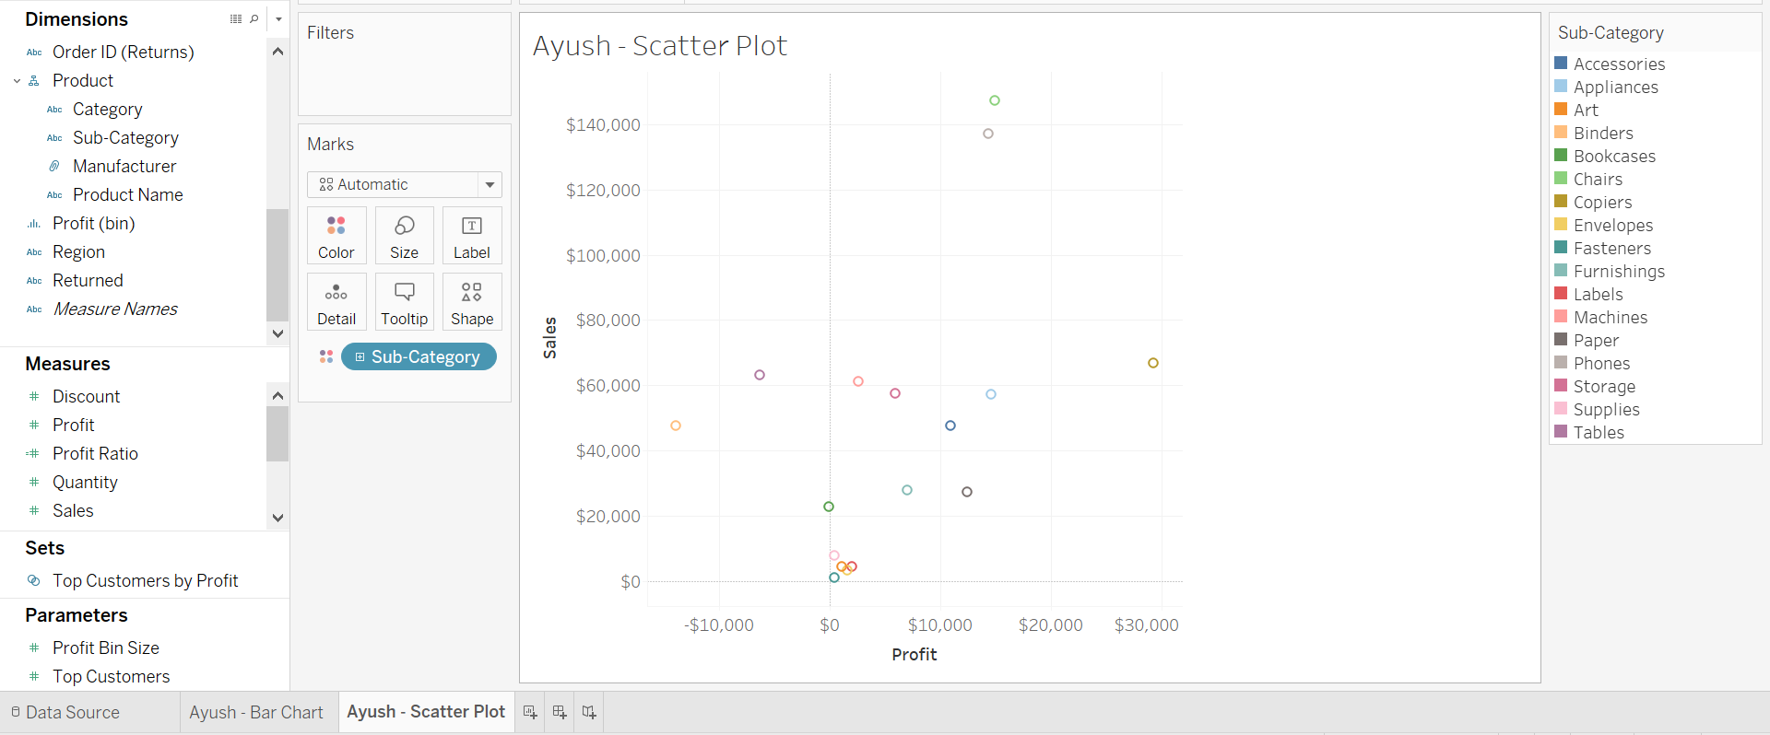

1. Drag “Order Date” from Dimensions to the Filters shelf.

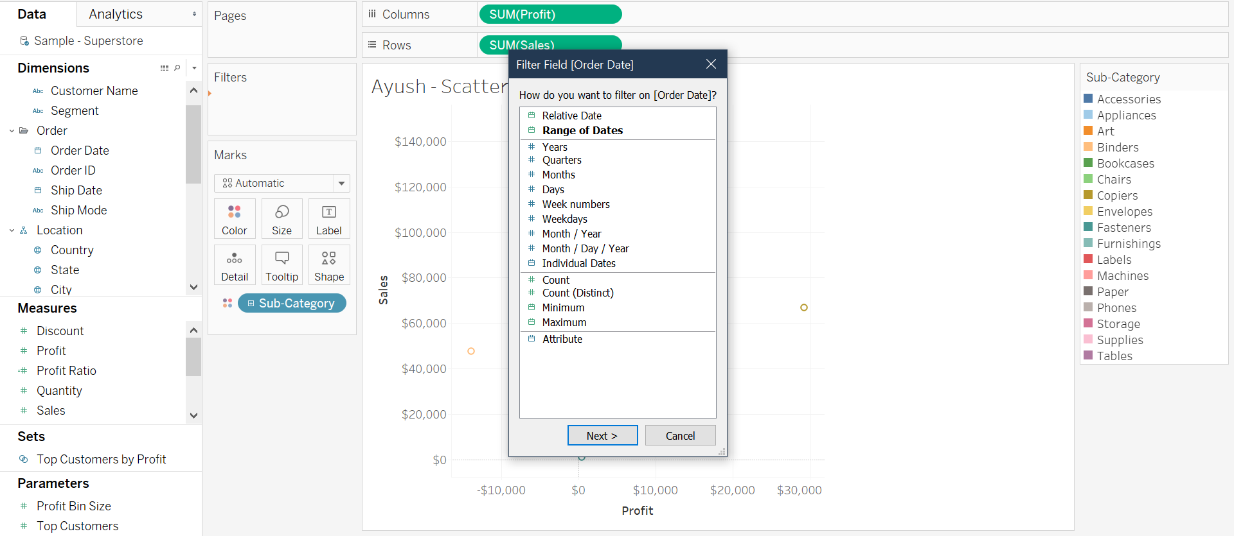

1. Click on “Years”. In the next pop-menu select 2016, 2017 and 2018. Finally, click on the apply button then hit Ok.
2. Hover the mouse on the newly created filter, click on the white triangle and select “Show Filter”.

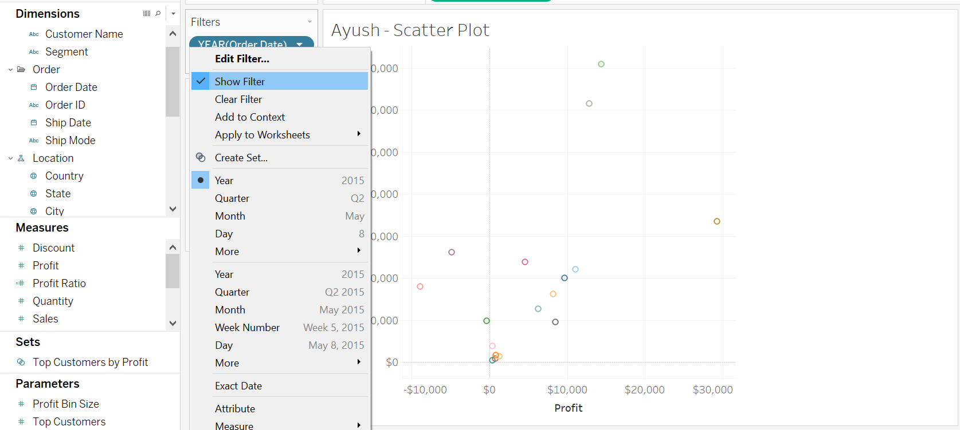

1. Hover mouse over the engaged filter on the right side. Click on small white triangle and de-select “Show All Value” from Customize.

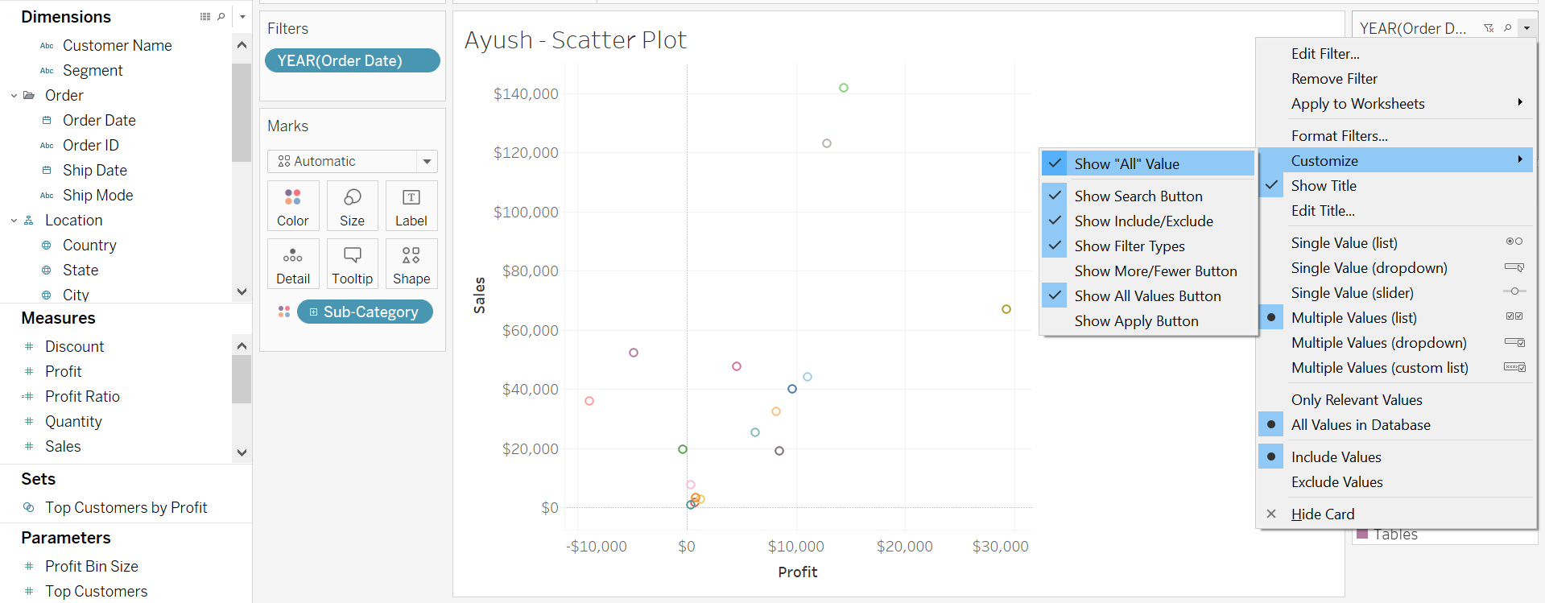

Question 8: Paste the screenshot of your screen showing the “Entire View”

Question 9: Which sub-category has sales greater than $140,000? Which sub-category has Profit greater than $10,000?

**Step 9: Histogram**

1. Create a new worksheet and rename it to “FirstName – Histogram”.
2. Drag “Quantity” from Measures to the Rows shelf.
3. Click on the “Show Me” tab on top right and select “Histogram”. Notice what happens to the visualization.

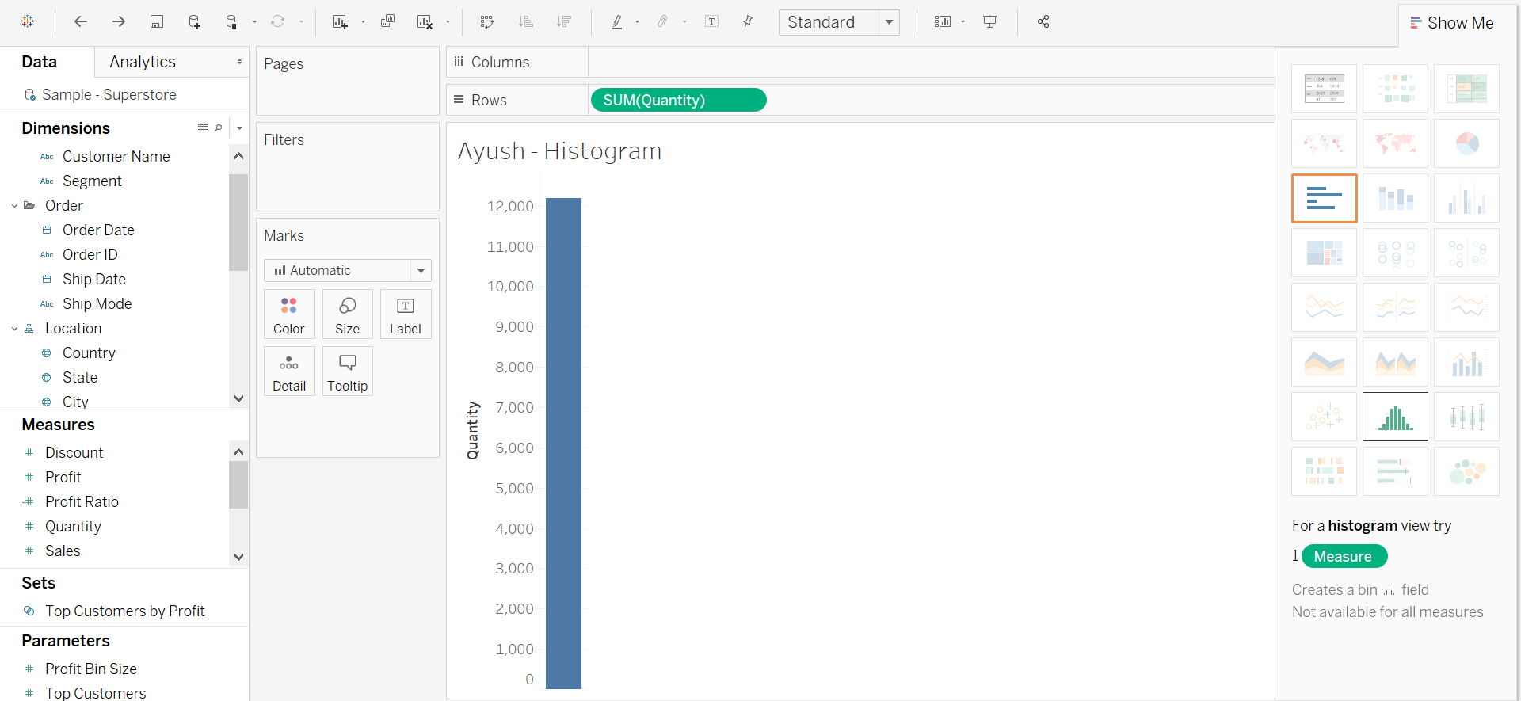

1. Right click on the bottom axis then click on “Edit Axis”.

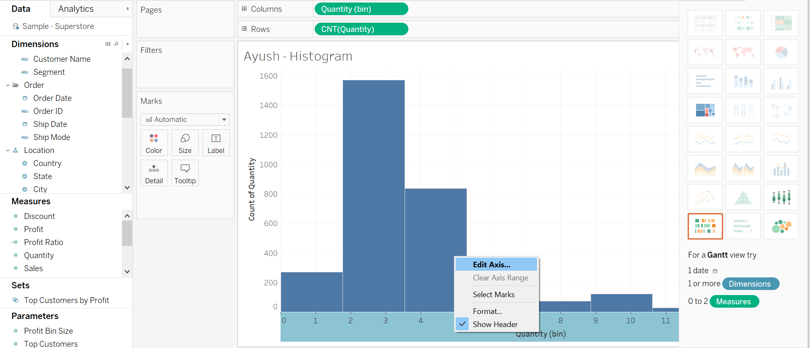

1. In the pop-menu click on the Tick Marks tab and select Fixed and change the major tick interval to the setting “0 to 3”.

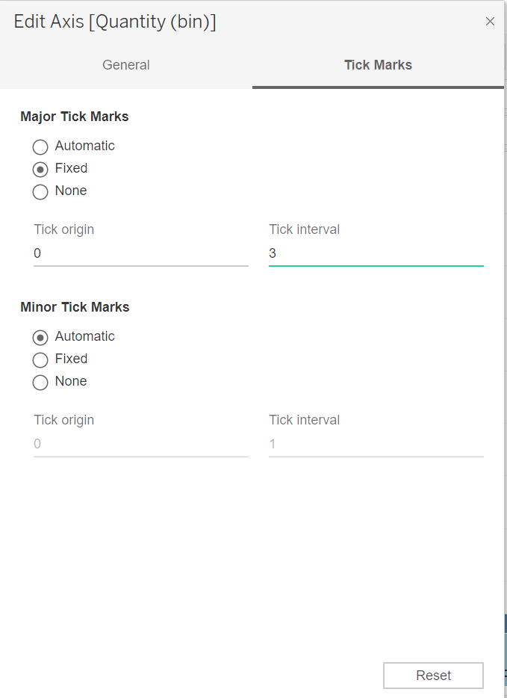

1. Right click on Quantity(bin) in Dimensions, then click on Edit.

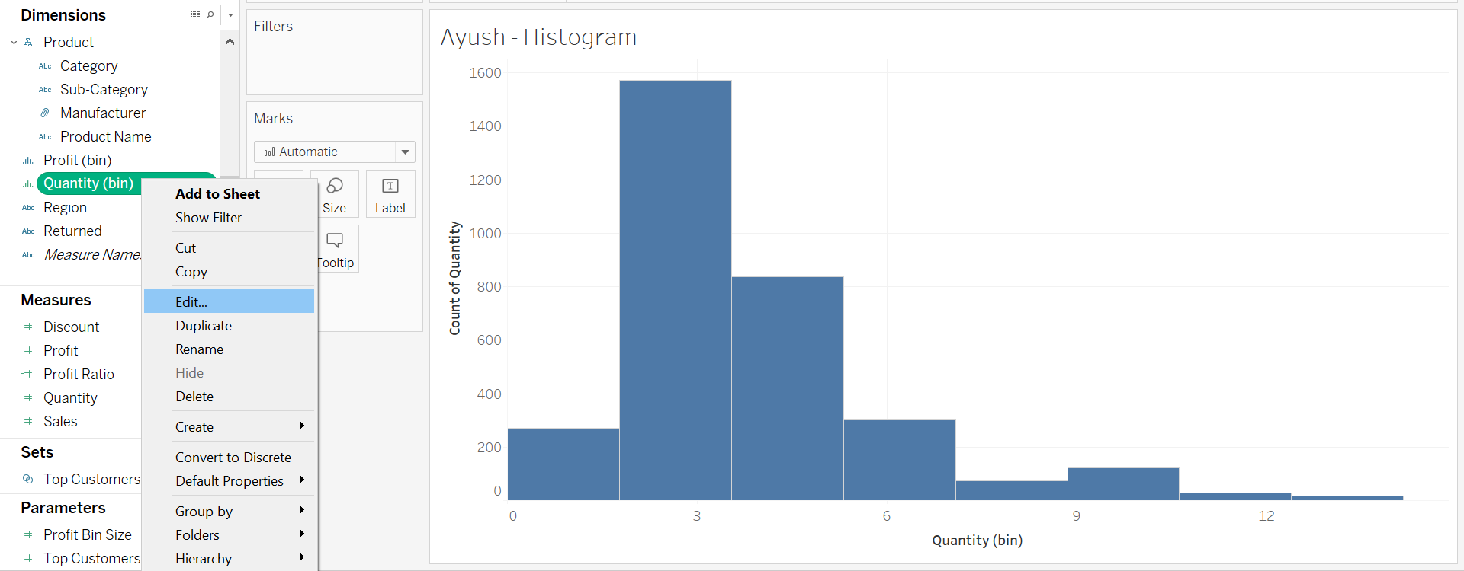

1. In the pop-up menu, set the size of bins to 3, then click on OK.

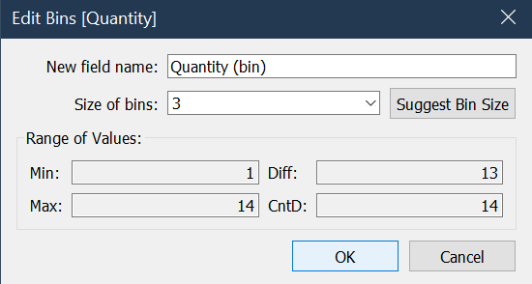

Question 10: Paste the screenshot of your current screen showing the “Entire View”.

**Step 10: Highlight Tables**

1. Create a new worksheet and rename it to “FirstName – Highlight Tables”.
2. Drag “Category” and “Sub-Category” from Dimensions to the Rows shelf in that order.

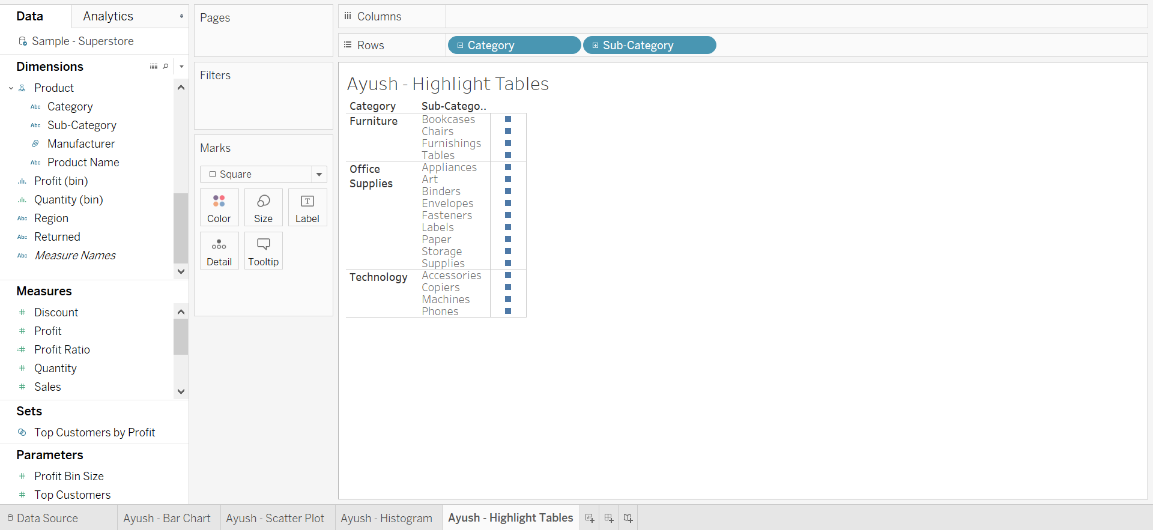

1. Drag “Profit” from Measures to the color mark.

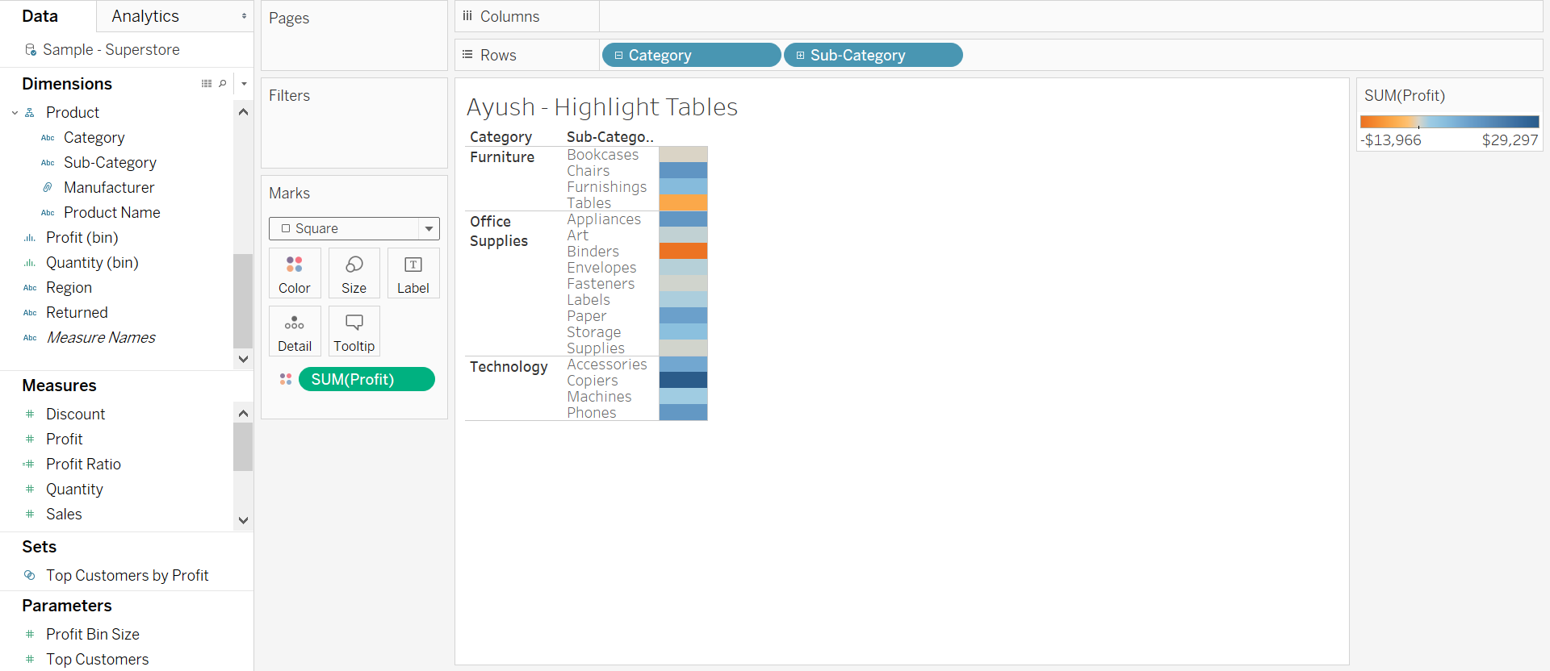

1. Drag “Profit” from Measures to the Label on the Marks shelf.

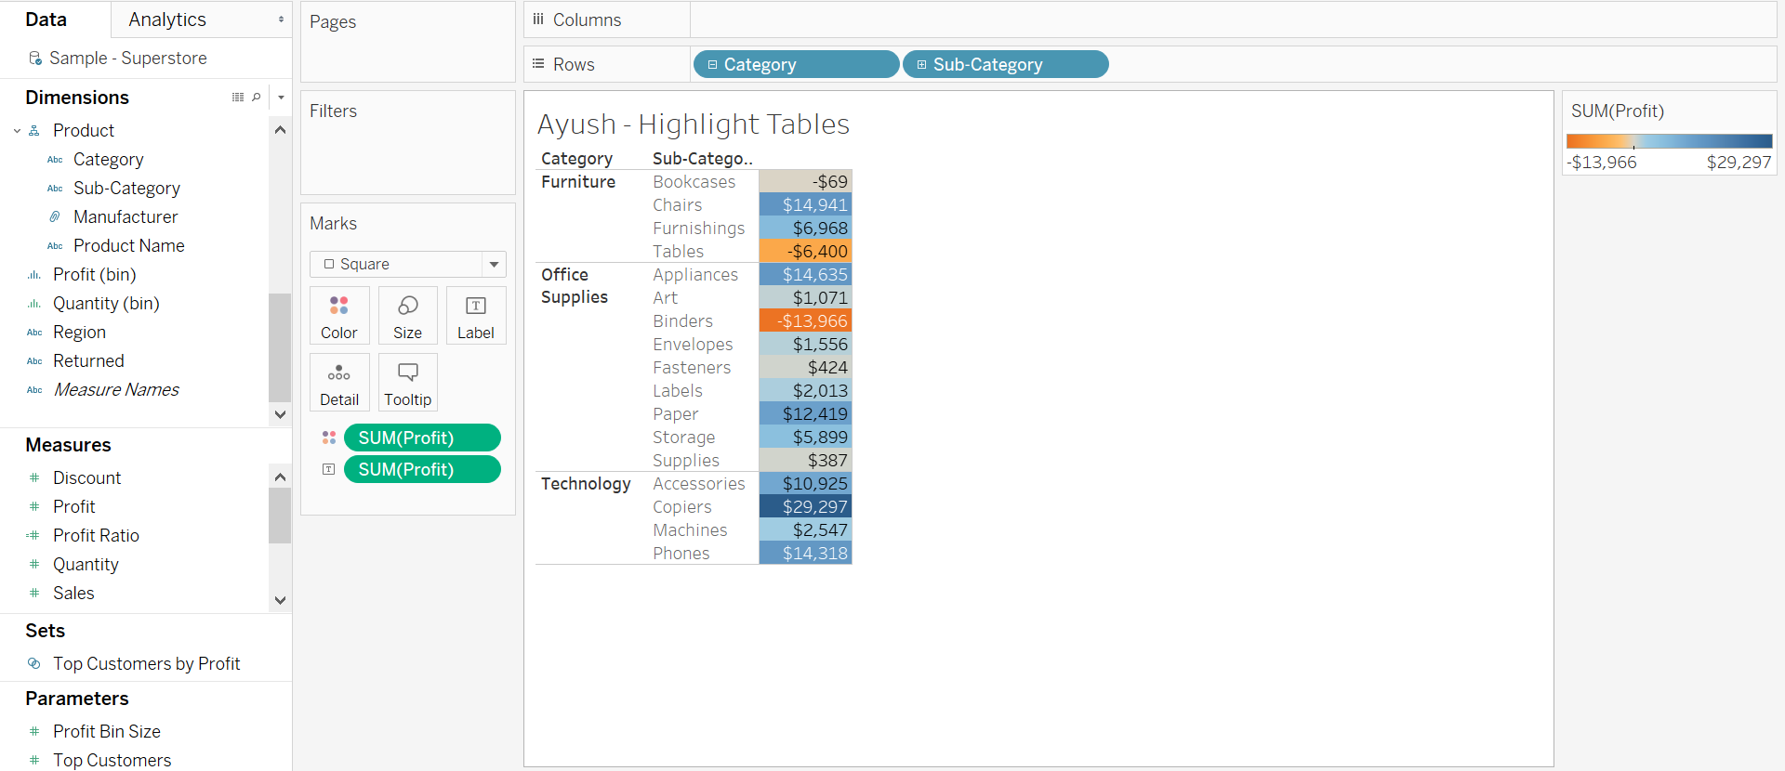

Question 11: Paste the screenshot of your screen.

Question 12: Which sub-categories are making the most profit? Which sub-categories are making the least profit? List 3 sub-categories with their corresponding values for each with your answers.

**Step 11: Sorting**

1. Create a new worksheet and rename it to “FirstName - Sales and Profit”.
2. Drag “Sub-Category” to the columns shelf. Drag “Sales” to the rows shelf.

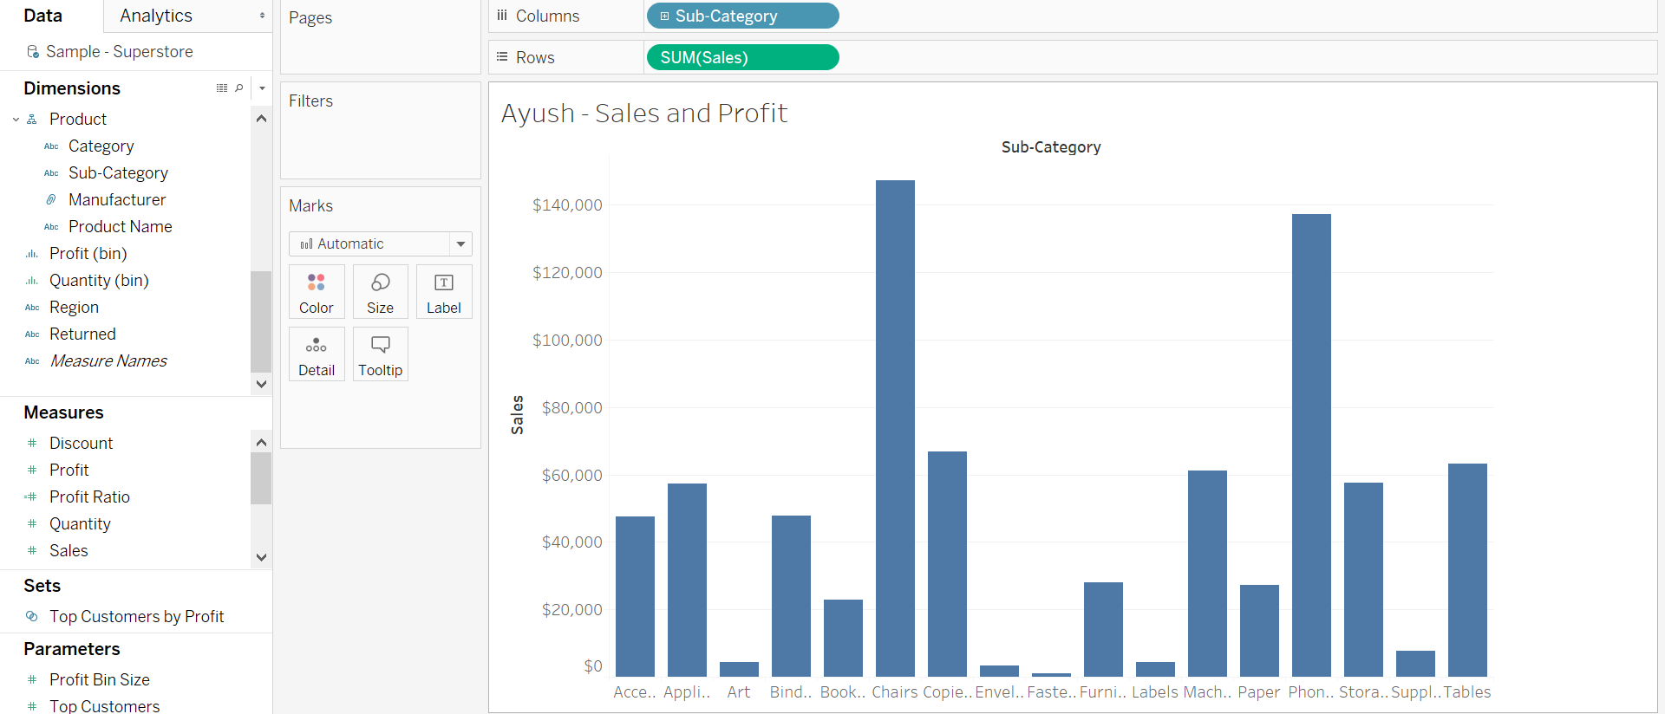

1. Hover your mouse over “Sub-Category” then click on the small white triangle and select Sort.

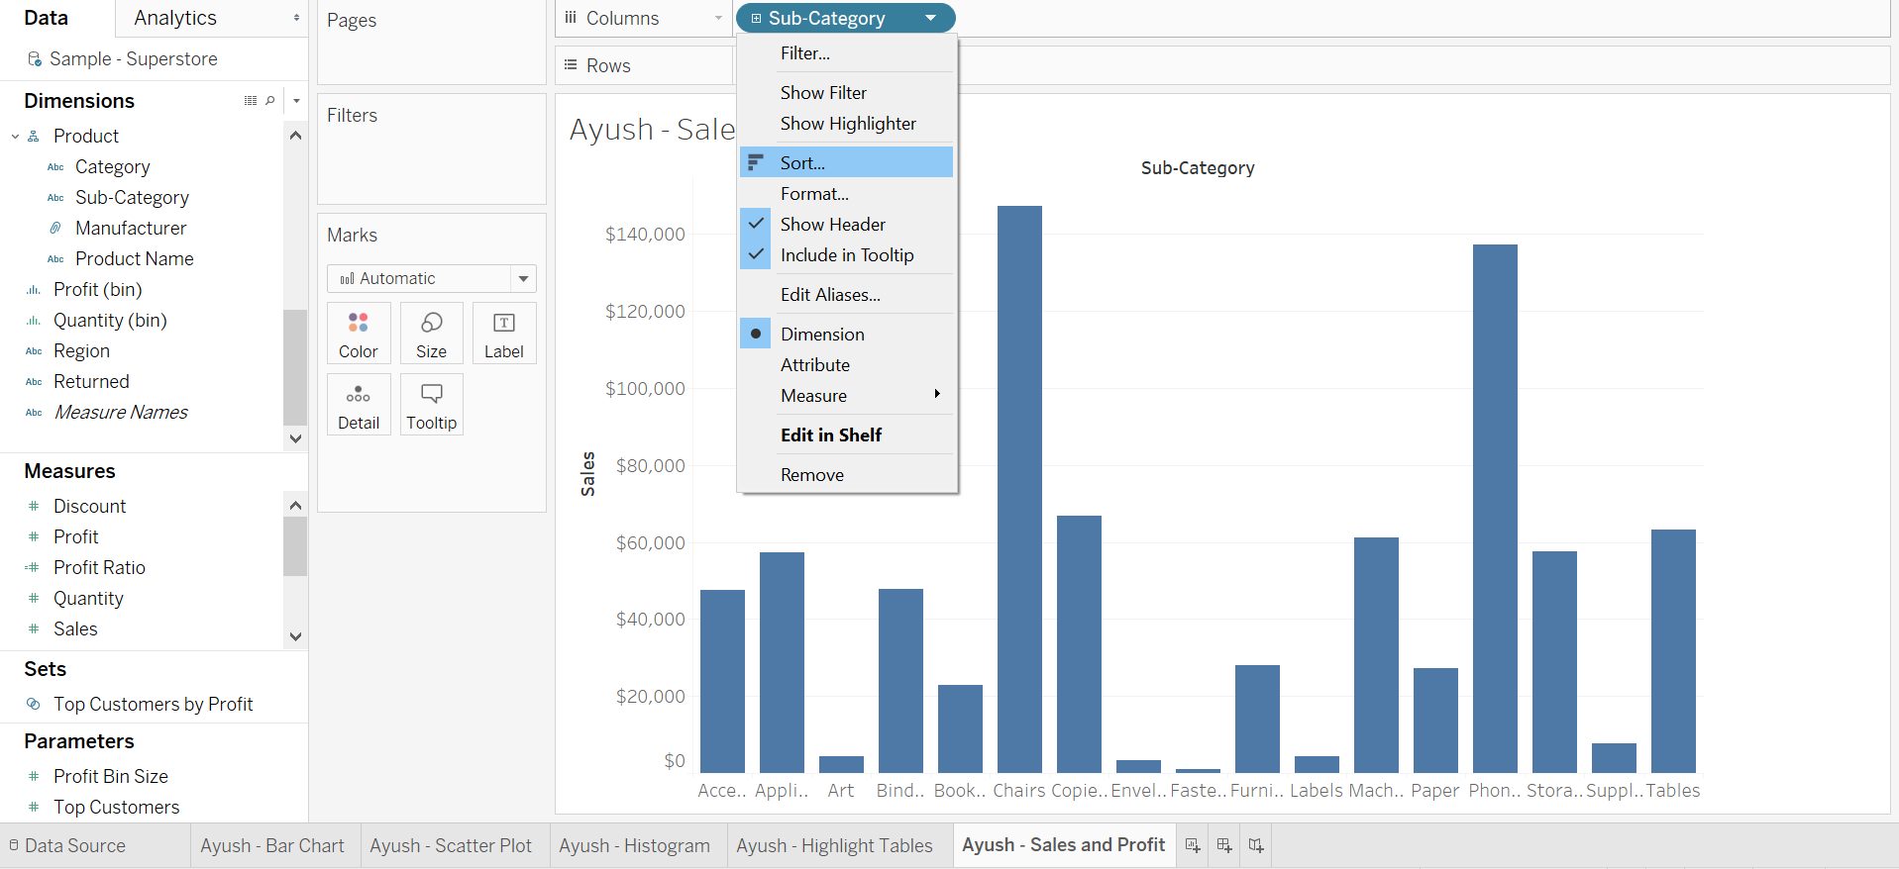

1. Within Sort, select “Field” as the data source order.

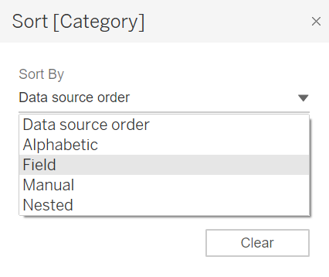

1. Change the sort order to Descending and select Profit for the field name.

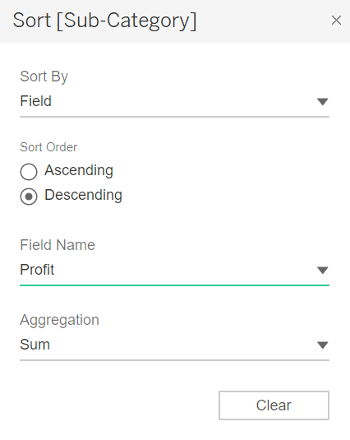

1. Drag “Profit” from Measures to Tooltip in the Marks shelf .

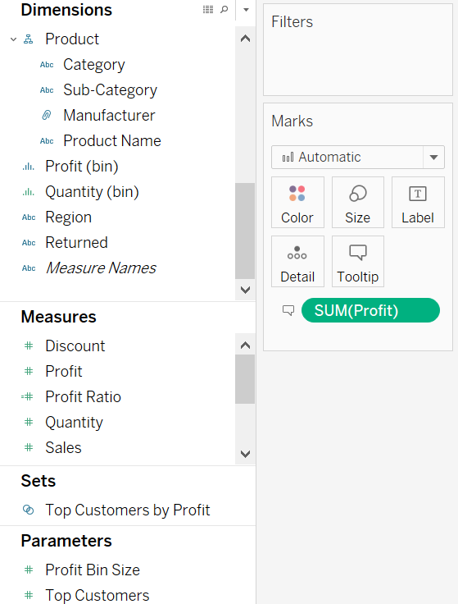

Question 13: Paste the screenshot of your screen showing the “Entire View”.

Question 14: Which sub-categories have the highest sales? Which sub-categories have the highest profits? List 3 sub-categories for each with their respective values.

Hint: Hover mouse over individual bars for profit and sales values.

From the File menu at the top left, save your file as “Firstname_Lastname”. **Make sure to save the file as .TWBX. Submissions using any other extension will receive heavy discounting.**

**Instructions:**

1. Submit the assignment document in Microsoft Word to eLearning.
2. Submit your TWBX file on eLearning .
3. Include only screenshots and answers with proper question numbers. For any additional step/instruction or improper question numbering your assignment will be discounted.